Salon Booking App Market Sizing

As per TRAI report of 2016-17 India has 400.4 million mobile wireless subscribers. As of end of 2017 there was 291.6 million smart-phone users as per [dazeinfo](https://dazeinfo.com/2018/05/07/smartphone-users-in-india-2018-2022-growth/).

From the data collected by StatCounter and analysis by [Statista](https://www.statista.com/statistics/262157/market-share-held-by-mobile-operating-systems-in-india/) and image below, we see that almost 75% of the market share is with android OS in 2017.

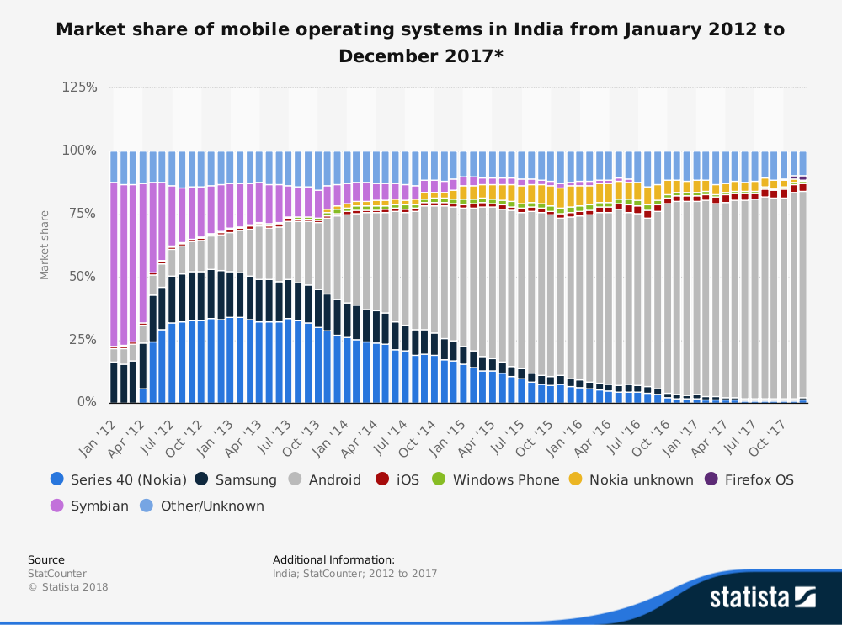

In terms of the number of hair salons and spas in India only a rough ballpark estimation can be made.

According to Pune based research firm ValueNotes Database and [business standard news](https://www.business-standard.com/article/companies/beauty-salons-are-big-business-104041501012_1.html), in 2013, India had over 61,000 beauty salons in towns with population of over 1 million.

To get a rough estimate we consider the total number of towns,villages and cities in India and multiply that with 7. From the 2011 census of India there are around 657913 cities, towns and villages. This brings more than 4,605,391 salons in India.

We can consider Karnataka to have around 40000 salons minimum with bangalore having around 7000 salons.